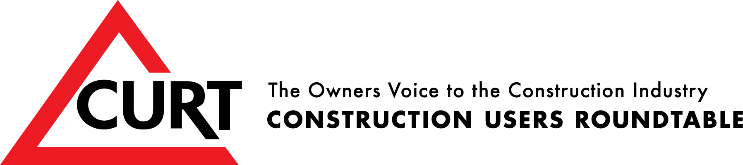

2019 WORKFORCE DEVELOPMENT AWARD APPLICATION

PART 1: Contact Information
(NOTE: It is essential that the contact people be both knowledgeable about the program and available to answer questions in a timely manner.)

Date: Program Name:
(As it will appear on the award)

Primary Contact  Name:  Title :  Organization:  Address:  City:  State:  Zip:  E-mail:  Phone:  Fax:  Website: | Secondary Contact  Name:  Title:  Organization:  Address:  City:  State:  Zip:  E-mail:  Phone:  Fax:  Website:

PART 2: Program Summary
(NOTE: The panel will use this information to select the programs that will be considered in greater depth in the next phase of the award selection process. Charts, graphs, or other illustrations may be embedded in Part 2 and must be included in the page count. The Workforce Development Committee advises that the programs submitted reflect all aspects of workforce development but with an emphasis on results.)

Mission Statement:

Target Objectives:

Means of Implementation:

Measurable Results:

PART 3: Minimum Qualifying Responses
(NOTE: Your Minimum Qualifying Responses are expected to be at most one paragraph long. Clear, concise answers are all that are needed at this time. These answers will be used by the jury to determine if your submission warrants further detailed investigation. In short, lengthy sales pitches will hurt rather than help this process. Charts, graphs, or other illustrations may be embedded in Part 3 and must be included in the page count.)

- How does your program effectively develop the workforce and benefit the industry through forecasting, recruitment, training, assessment, and retention?

- Give a concise description of the way that senior management, both in your organization and in participating organizations and groups, supports your program.

- Concisely describe the ways that your program demonstrates performance and results through innovative and unique processes. (This is not about program offerings and spending, it is about effective means of attracting and placing workers in construction industry jobs, demonstrating a benefit to the individual and to the contractor.)

- Explain how your program develops and enhances the recruited individual’s skills in the construction industry utilizing innovative techniques and methods.

- Describe the ways that your program supports and promotes a long term view of employment in a construction career track, the value of work, work ethic, and diversity.

- Describe how your program demonstrates and promotes a commitment to openness and inclusiveness to diverse population groups.

- Provide the evidence that the program is underway, operational, and successful.

- Share up to three examples of issues, events, or barriers that were critical to the success of your program.

- What do you consider to be the specific aspects of your program that could be identified as a best practice for the industry?

- Please list the CURT member companies, if any, that participate in the program and provide the primary contact information for each.

PART 4: Process Feedback
Please give us any suggestions that you might have for ways in which we can improve the process of submitting an application for the award.

